Hospital Ratings & Characteristics: A Medicare Data Analysis

Examining CMS Hospital Ratings Based on Hospital Features & Payment Patterns

Student: Uttara Bammireddy
Course: MIS 6940 - Project Seminar
Instructor: Dr. Venugopal Balijepally
Date: December 2025

Abstract

This research investigates factors influencing Hospital Overall Ratings within the U.S. healthcare industry using Medicare data obtained from the CMS website. The study focuses on understanding how characteristics such as hospital location (metro vs. non-metro), ownership type (government or private), availability of emergency services, presence of acute care services, Major Diagnostic Categories (MDCs), and Medicare Spending per Beneficiary (MSPB) Score impact the overall quality ratings assigned to hospitals. Multiple statistical and machine learning models including linear regression, ordinal logistic regression, decision trees and random forests were applied to identify important predictors and evaluate performance. The results highlight Score and major diagnostic categories as strong predictors. This research supports healthcare administrators in understanding drivers of quality ratings and guides future improvements.

Comparative Analysis of Medicare Hospital Quality Ratings

Organization / Industry Description

The U.S. healthcare industry is a complex and expansive system that delivers a wide range of medical services through both public and private institutions. A major component of this system is Medicare, the federally funded health insurance program administered by the Centers for Medicare & Medicaid Services (CMS). Medicare primarily serves individuals aged 65 and older, as well as certain younger individuals with disabilities, covering over 65 million beneficiaries across the country.

Hospitals play a critical role in this system by providing inpatient and outpatient care, emergency services, surgical procedures, and specialized treatments. These services are reimbursed by Medicare through structured payment systems, which form a sizeable portion of hospital revenue. To promote accountability and transparency, CMS regularly publishes comprehensive data on hospital characteristics, quality ratings, cost metrics, and spending patterns via its Provider Data Catalog (PDC).

This data supports healthcare providers, policymakers, and researchers in understanding trends, identifying disparities, and improving the quality and efficiency of care within the Medicare framework.

Research Questions

The Centers for Medicare & Medicaid Services (CMS) assigns hospital overall ratings to help patients compare facilities based on the quality of care delivered. These ratings are widely used in decision-making by patients, payers, and policymakers. However, hospital ratings may be shaped by underlying structural and financial characteristics such as location, ownership, service availability, case mix, and spending efficiency. Understanding how these factors relate to ratings can help uncover potential disparities or performance trends.

This project explores how hospital characteristics and financial indicators influence overall ratings. Specifically, it investigates:

- Are hospitals located in metro areas more likely to receive higher overall ratings than non-metro hospitals?
- How does ownership type (government-owned vs. private) affect hospital ratings?
- What role do emergency services and acute care services play in shaping a hospital's overall rating?
- Do hospitals with a focus on certain Major Diagnostic Categories (MDCs) tend to receive better or worse ratings?
- How does the Score (MSPB - Medicare Spending Per Beneficiary), a measure of cost-efficiency, correlate with hospital overall ratings?
- Are there combinations of characteristics (e.g., metro location + low MSPB + specific MDC focus) that consistently predict higher-rated hospitals?

Sponsors

This project was conducted under the guidance of Professor Venugopal Balijepalli as part of the MIS 6940 Project Seminar at Oakland University. He provided support in defining the research focus, identifying relevant CMS data sources, shaping the analysis approach, and reviewing findings throughout the project to ensure alignment with the project’s goals.

Method

The data for this research was sourced from the Centers for Medicare & Medicaid Services (CMS) Provider Data Catalog (PDC). Three primary datasets were downloaded and integrated for this project:

- Hospital General Information
- Medicare Inpatient Hospitals - by Provider and Service (DRG - Level)
- Medicare Spending Per Beneficiary (MSPB) - Hospital

These datasets are publicly available and provide hospital-level and service-level details across the U.S.

Data Preparation and Cleanup (Appendix A)

Initial data cleanup was performed using Excel, followed by integration and transformation using Microsoft Access. A consolidated hospital-level dataset with approximately 5,400 records was created by merging the necessary fields from all sources.

Key variables used in the analysis include:

- Hospital Ownership Type (Private or Government)
- Metro Area Classification
- Availability of Emergency and Acute Care Services
- MSPB Score (a standardized metric of Medicare spending per beneficiary)
- Average Medicare Payments
- MDC Codes (Major Diagnostic Categories)
- Hospital Overall Rating (used as the main outcome variable)

Statistical Analysis (Appendix C & D)

An initial correlation analysis was conducted in SPSS to evaluate relationships between hospital ratings and the listed variables. Based on this, a subset of strong predictors was selected.

The following models were used:

- Multiple Linear Regression
- Ordinal Regression (to account for the ordered nature of hospital ratings)

These were applied in SPSS to understand how different hospital-level characteristics influence ratings.

Machine Learning Techniques (Appendix E & F & G)

To support and validate findings from regression models, Decision Trees and Random Forest classifiers were also applied to the final dataset.

Visualization and Reporting (Appendix H)

A Power BI report was developed to communicate the results through interactive visuals. It includes:
- Analysis by Care Type and Ownership
- State-wise breakdown of Average Medicare Payments
- Rating and Payment distributions
- Comparison across MDC categories

Project Deliverables / Findings

This project delivered a comprehensive analysis of how hospital characteristics influence their CMS Hospital Overall Rating. Using data from the CMS Provider Data Catalog, multiple analytical methods were applied to uncover meaningful patterns and predictors. The key deliverables and findings are as follows:

Integrated Hospital Dataset (Appendix A)

I have compiled a unified dataset by merging three publicly available CMS datasets:

- Hospital General Information
- Medicare Inpatient Discharge Data (by Provider & Service)
- Medicare Spending per Beneficiary (MSPB)

The final dataset contained approximately 5,400 hospitals with variables such as:

- Ownership (Government vs. Private)
- Metro area status (Urban vs. Non-Urban)
- Availability of Emergency Services and Acute Care
- Average Medicare Payments
- Medicare Spending per Beneficiary Score (MSPB Score)
- Discharge volumes across MDC Categories

  - MDC_4: Respiratory System
  - MDC_5: Circulatory System
  - MDC_8: Musculoskeletal System
  - MDC_18: Infectious & Parasitic Diseases
  - MDC_10: Endocrine, Nutritional & Metabolic Diseases

Preliminary Correlation Analysis (Appendix C)

Using SPSS, initial correlation testing revealed:

- Metro hospitals had higher average ratings compared to non-metro ones.
- Government-owned hospitals were slightly more likely to have lower ratings than private ones.
- Higher MSPB Scores (spending per beneficiary) tended to correlate with lower hospital ratings.
- Hospitals with Emergency or Acute Care services showed rating variation, though not always significant.
- Certain MDC volumes (especially MDC_5 and MDC_18) had strong associations with lower scores.

Regression & Ordinal Regression Modeling (Appendix D)

Three models were developed using SPSS.

- Model 1 & 2: Multiple Linear Regression
- Model 3: Ordinal Logistic Regression (PLUM)

Key Findings

- Metro area status had a significant positive impact on hospital rating.
- MSPB Score was a strong negative predictor, showing that higher spending per beneficiary is associated with lower ratings.
- Among MDC categories, MDC_18 (Infectious & Parasitic) and MDC_5 (Circulatory) consistently showed significant impact.
- GovernmentCare had a small but negative influence on ratings.
- Adjusted R² values for linear models were modest (~12.6% and 12.3%), indicating moderate explanatory power.

Classification Trees (Decision Tree & Random Forest Models) (Appendix E & F & G)

I have developed four classification models to predict hospital rating class (1 - 5):

- Decision Tree 70/30 Split
- Decision Tree 80/20 Split
- Random Forest 70/30 Split
- Random Forest 80/20 Split

Accuracy & Key Predictors

Model | Accuracy | Weighted F1 | Key Predictors
Decision Tree 80/20 | 0.3003 | 0.253 | Score, MDC_5, MDC_18, MDC_8, MDC_4
Decision Tree 70/30 | 0.3235 | 0.298 | Score, MDC_5, MDC_18, MDC_8, MDC_4
Random Forest 80/20 | 0.3629 | 0.347 | Score, MDC_5, MDC_18, MDC_8
Random Forest 70/30 | 0.3148 | 0.295 | Score, MDC_5, MDC_18, MDC_8

- Random Forest (80/20) performed best overall in terms of accuracy and F1-score.
- Models struggled to classify lower-rated hospitals accurately (Class 1 & 2), due to class imbalance.
- Score, MDC_18, MDC_5, and MDC_8 emerged as top predictors across all models.

Rule-Based Insights from Decision Trees

Decision Tree models also uncovered interpretable rules. For example:

- Hospitals with Score ≥ 0.97 and MDC_18 discharges > 42,000 were consistently linked to lower hospital ratings.
- Metro area hospitals with moderate spending and lower MDC_18 volumes were more likely to fall into rating classes 3 - 4.

Visual Summaries & Model Interpretations

- Decision Tree and Random Forest variable importance plots visually confirmed MSPB Score and MDC_18 as dominant influencers.
- Regression output charts showed consistent statistical significance (p < 0.01) for Score, Metro status, and MDC_18 across all models.

Research Evaluation

This research addresses key challenges in the healthcare industry, particularly in understanding what drives variations in hospital quality ratings. CMS ratings are publicly visible and heavily influence patient trust, funding decisions, and hospital reputation. However, the factors that influence these ratings are not always transparent to hospital administrators or policymakers.

The findings from this project provide a data-driven explanation of how specific hospital characteristics like Medicare spending efficiency (MSPB Score), geographic location, and patient volumes for certain disease categories (MDCs) are statistically linked to overall ratings. Identifying these predictors helps stakeholders pinpoint where to focus improvements.

The regression models confirmed that higher spending per beneficiary often correlates with lower hospital ratings, suggesting inefficiencies in resource use. The ordinal model strengthened this insight by estimating rating thresholds based on predictor values. Meanwhile, the classification models though moderate in accuracy helped define patterns, such as how high discharge volumes in infectious or circulatory disease categories are often tied to lower ratings.

Hospitals can use these insights to:

- Benchmark themselves against similar institutions.
- Investigate specific departments (e.g., high-volume infectious disease cases) that may be impacting ratings.
- Optimize resource utilization to improve their MSPB scores and, by extension, their CMS ratings.

This analysis can support better decision-making in hospital management, Medicare policy design, and quality improvement strategies across the industry.

Lessons Learned

This project gave me hands-on experience with managing large, real-world healthcare datasets and applying advanced analytics to draw meaningful insights. One of the key lessons was the importance of thorough data preparation merging multiple CMS datasets, cleaning variables, and building a usable hospital-level dataset took more time than expected.

I also learned that statistical significance doesn't always translate to practical impact. For example, while some predictors like metro status and score were statistically significant, their real-world effects varied depending on context highlighting the need to interpret results carefully and not rely on coefficients alone.

Working with regression and classification models in SPSS taught me how different techniques can complement each other. Linear and ordinal regression helped quantify relationships, while decision trees and random forests offered pattern recognition and prediction even when accuracy was modest.

Lastly, using visualization tools like Power BI helped bring the data to life, making it easier to communicate results to non-technical audiences. Overall, this project deepened my understanding of both the technical and strategic sides of data analytics in healthcare.

Limitations & Future Work

One major limitation of this research was the overall model accuracy, especially for classification (decision trees and random forest), remained modest around 30 - 36%. This suggests that the predictors used, though statistically significant in some models, don’t fully explain the variability in hospital ratings. Future work could explore additional features or alternative modeling techniques such as ensemble methods or neural networks for better performance.

Another limitation was the imbalance in class distribution of hospital ratings, which likely affected model performance. Also, some variables like Score or MDC codes were treated independently. However, interactions between predictors might hold valuable insights and should be explored using interaction terms or multivariate approaches.

Lastly, while SPSS and Power BI were sufficient for current needs, integrating tools like R or Python for modeling and dashboard automation could improve flexibility and scalability going forward.
Future work can also look into longitudinal analysis, tracking how ratings and cost patterns evolve over time, or perform geospatial analysis to identify regional disparities in care quality and costs.

References

- Centers for Medicare & Medicaid Services (CMS). Hospital General Information Dataset. Hospital General Information | Provider Data Catalog
- Centers for Medicare & Medicaid Services (CMS). Medicare Spending Per Beneficiary - Hospital. Medicare Spending Per Beneficiary - Hospital | Provider Data Catalog
- Centers for Medicare & Medicaid Services (CMS). Medicare Inpatient Hospitals - by Provider and Service. Medicare Inpatient Hospitals - by Provider and Service | CMS Data
- CMS Data Dictionary for Hospital Datasets. Data Dictionary
- MDC MDC & MS-DRG. MS-DRG

Appendixes

Appendix A - Data Model Overview

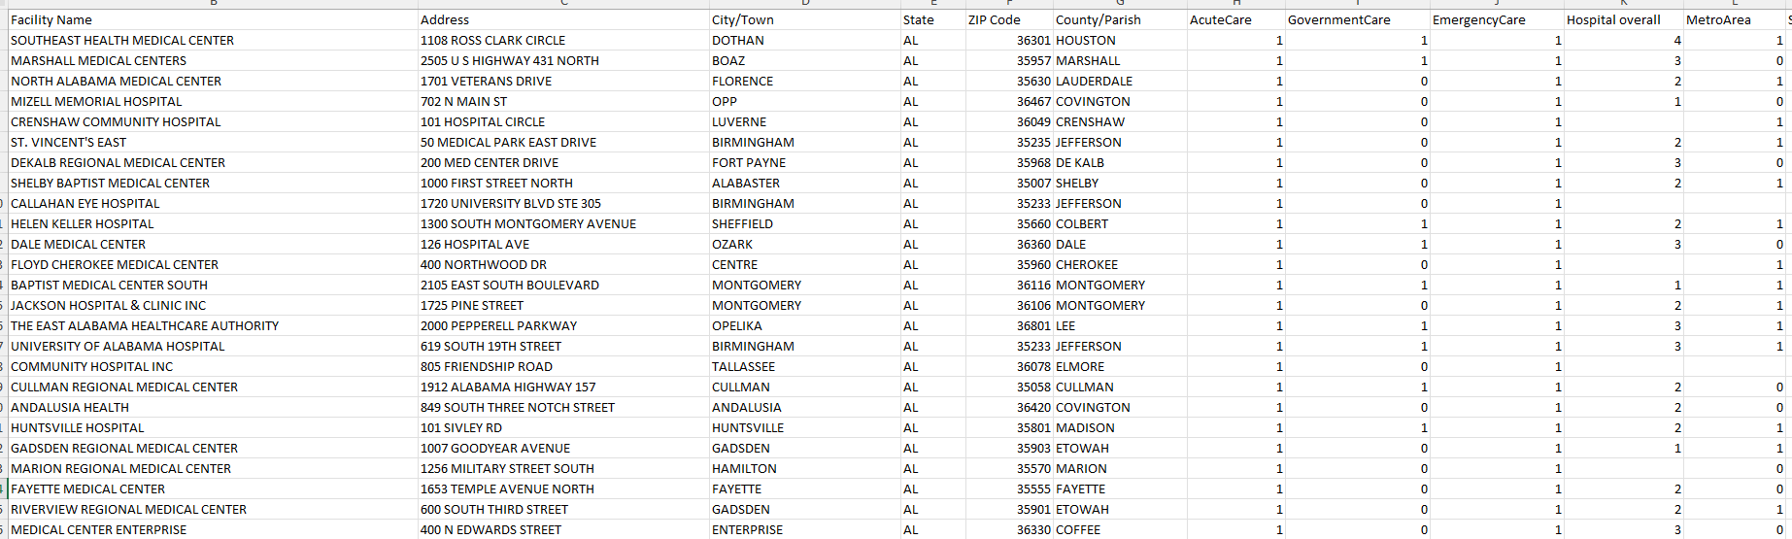

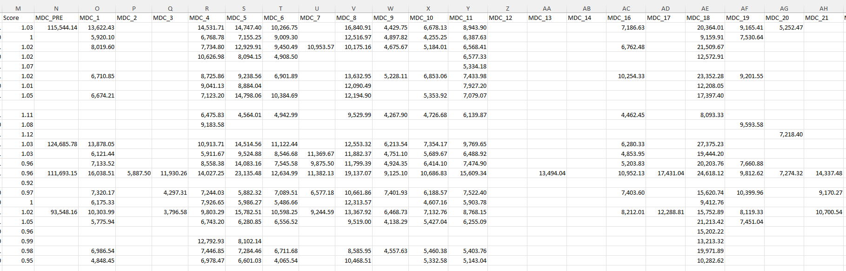

Appendix B - Variable Summary Table

Variable Name | Description
Facility ID | Unique identifier for each hospital facility
Facility Name | Official name of the hospital facility
Address | Street address of the hospital
City/Town | City or town where the hospital is located
State | U.S. state where the hospital is located
ZIP Code | Postal ZIP code of the hospital location
County/Parish | County or parish of the hospital's location
AcuteCare | Indicates if the hospital provides acute care services (1) or no (0)
GovernmentCare | Indicates if the hospital is government-owned (1) or privately-owned (0)
EmergencyCare | Indicates if the hospital has an emergency department (1) or no (0)
Hospital overall rating | CMS Overall Hospital Rating (1 - 5 scale) summarizing quality and patient outcomes
MetroArea | Indicates whether the hospital is located in a metropolitan (urban) area (RUCA >= 3 as 1 else 0)
Score | MSPB (Medicare Spending per Beneficiary)  score: composite metric of cost-efficiency (higher = worse performance/ higher costs)
MDC_PRE | Average Medicare payment for pre-major diagnostic category services
MDC_1 | Average payment for Diseases & Disorders of the Nervous System
MDC_2 | Average payment for Diseases & Disorders of the Eye
MDC_3 | Average payment for Diseases & Disorders of the Ear, Nose, Mouth & Throat
MDC_4 | Average payment for Diseases & Disorders of the Respiratory System
MDC_5 | Average payment for Diseases & Disorders of the Circulatory System
MDC_6 | Average payment for Diseases & Disorders of the Digestive System
MDC_7 | Average payment for Diseases & Disorders of the Hepatobiliary System & Pancreas
MDC_8 | Average payment for Diseases & Disorders of the Musculoskeletal System & Connective Tissue
MDC_9 | Average payment for Diseases & Disorders of the Skin, Subcutaneous Tissue & Breast
MDC_10 | Average payment for Endocrine, Nutritional & Metabolic Diseases & Disorders
MDC_11 | Average payment for Diseases & Disorders of the Kidney & Urinary Tract
MDC_12 | Average payment for Diseases & Disorders of the Male Reproductive System
MDC_13 | Average payment for Diseases & Disorders of the Female Reproductive System
MDC_14 | Average payment for Pregnancy, Childbirth & the Puerperium
MDC_16 | Average payment for Diseases & Disorders of Blood, Blood Forming Organs, Immunological Disorders
MDC_17 | Average payment for Myeloproliferative Diseases & Disorders, Poorly Differentiated Neoplasm
MDC_18 | Average payment for Infectious & Parasitic Diseases, Systemic or Unspecified Sites
MDC_19 | Average payment for Mental Diseases & Disorders
MDC_20 | Average payment for Alcohol/Drug Use & Alcohol/Drug Induced Organic Mental Disorders
MDC_21 | Average payment for Injuries, Poisonings & Toxic Effects of Drugs
MDC_22 | Average payment for Burns
MDC_23 | Average payment for Factors Influencing Health Status & Other Contacts with Health Services
MDC_24 | Average payment for Multiple Significant Trauma
MDC_25 | Average payment for Human Immunodeficiency Virus Infections

Appendix C - Preliminary Correlation Matrix (SPSS Output)

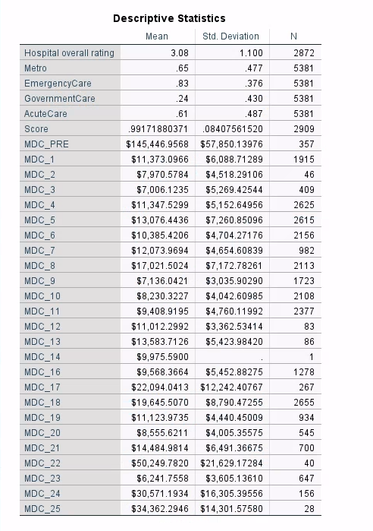
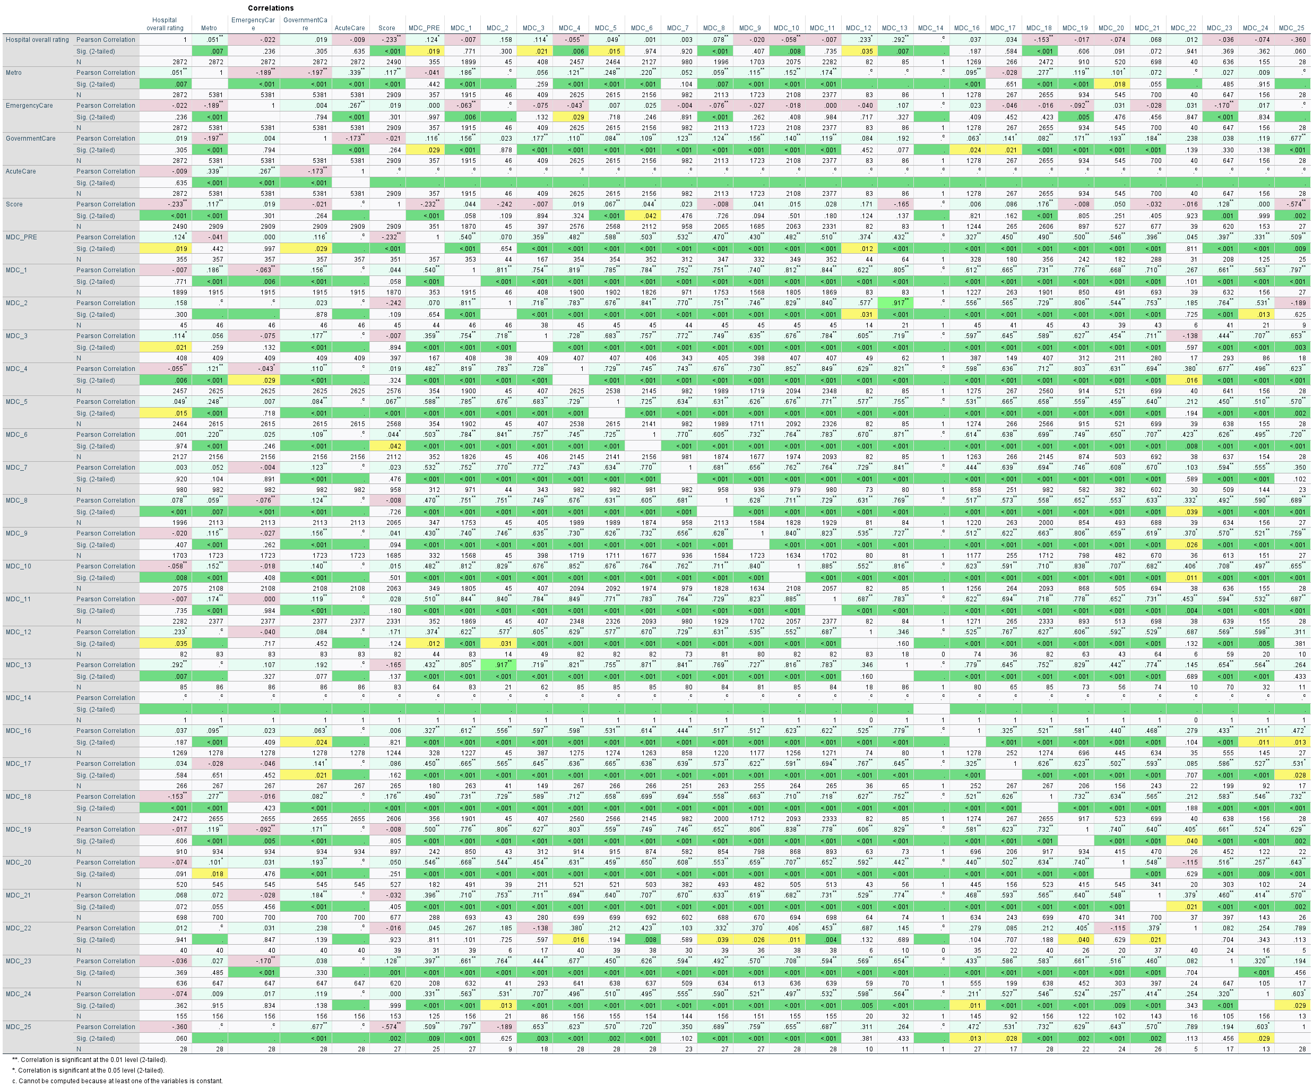

Appendix D - Model Summary Tables

Regression Models

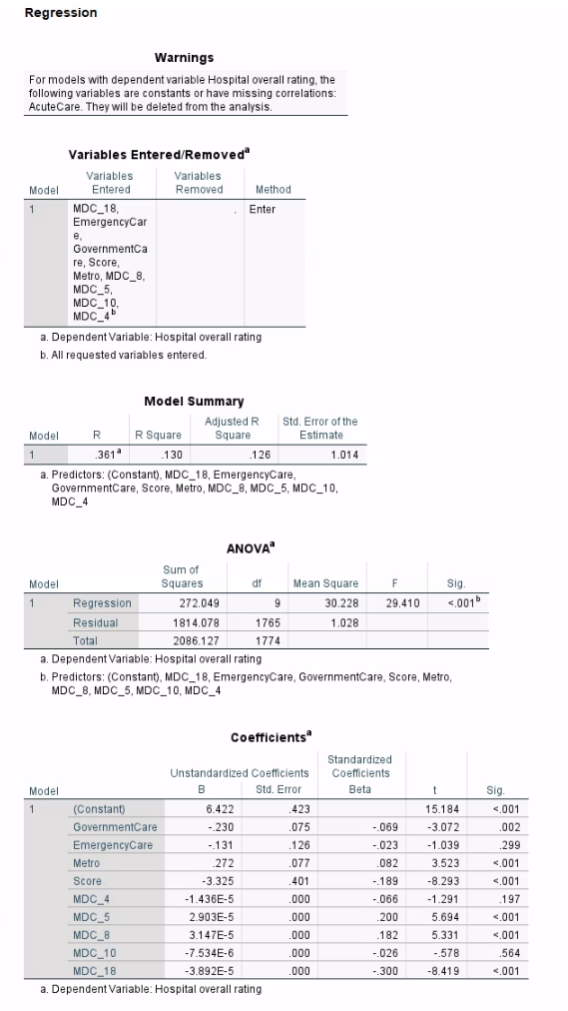
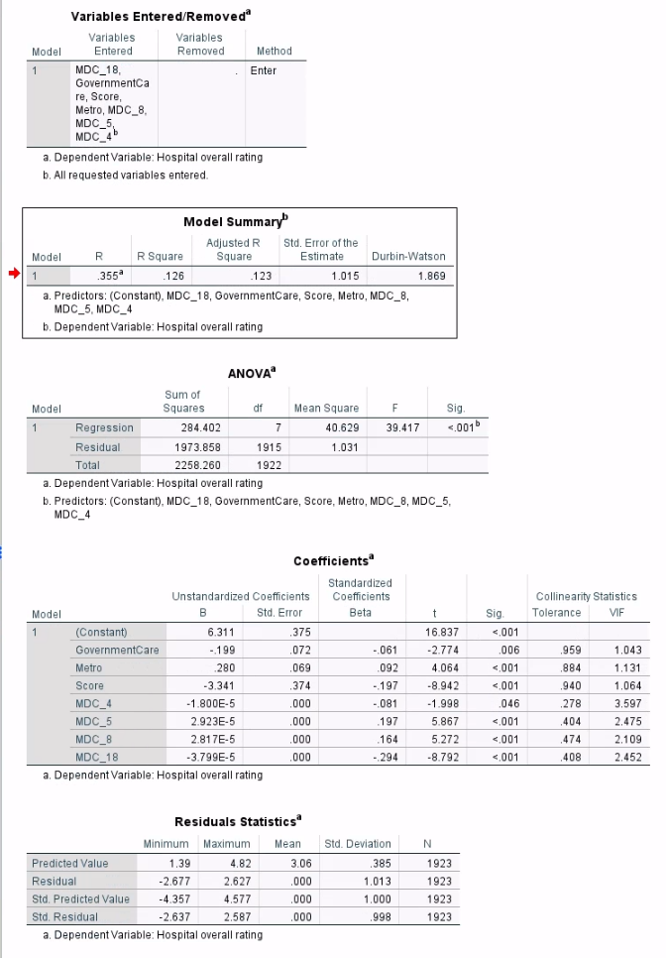

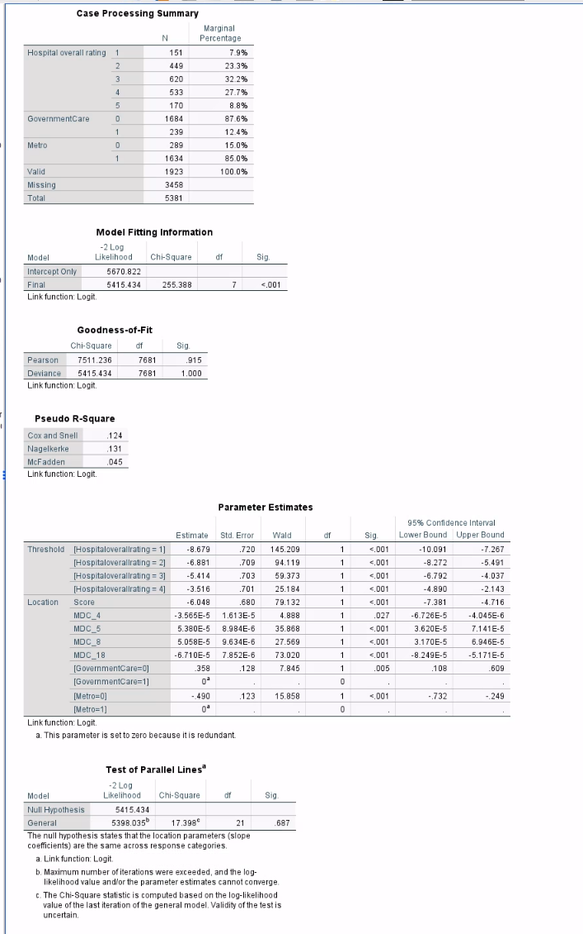
Appendix E - Decision Trees & Random Forest Confusion Matrices

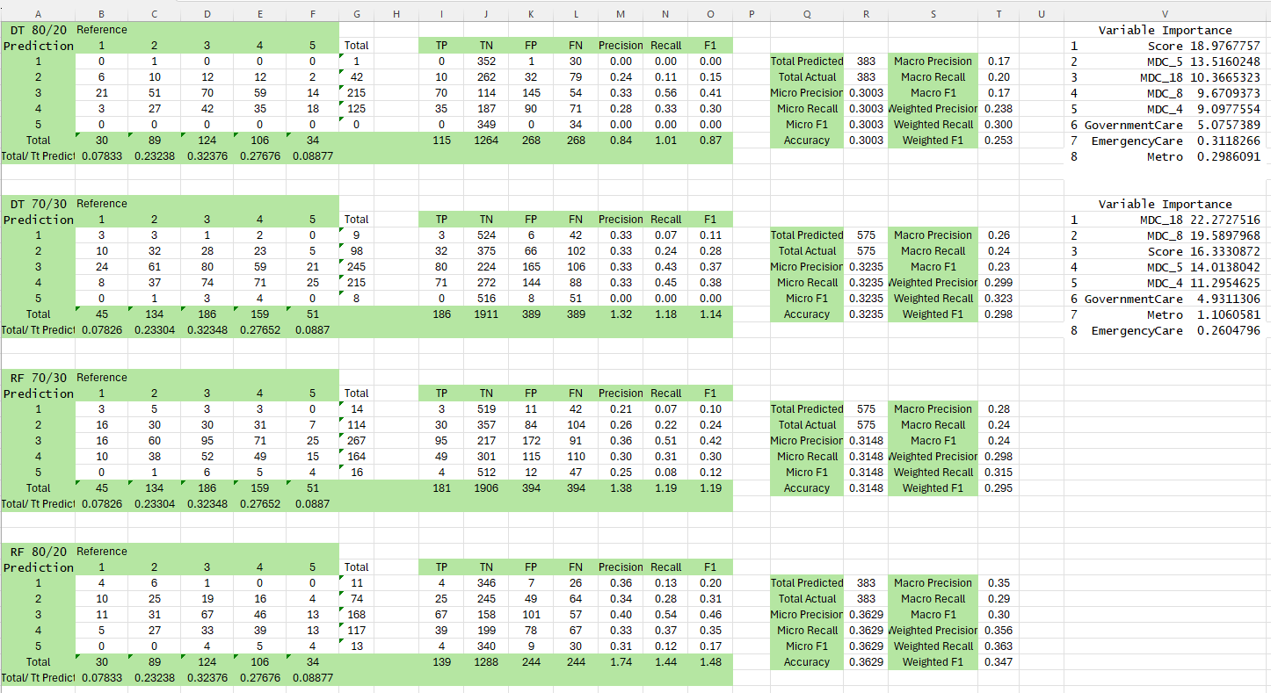

Appendix F - Decision Tree Plots

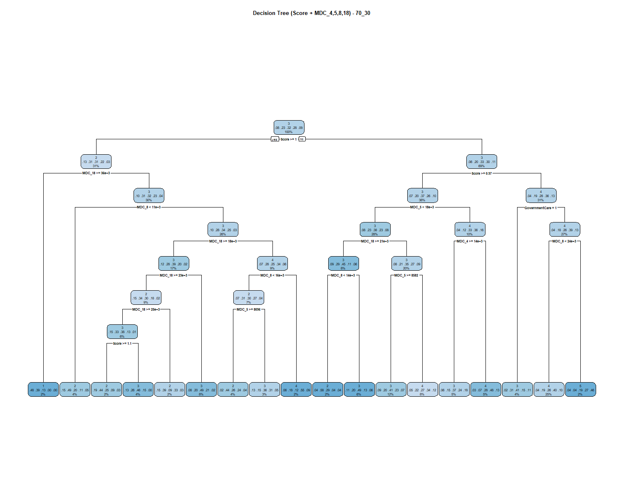
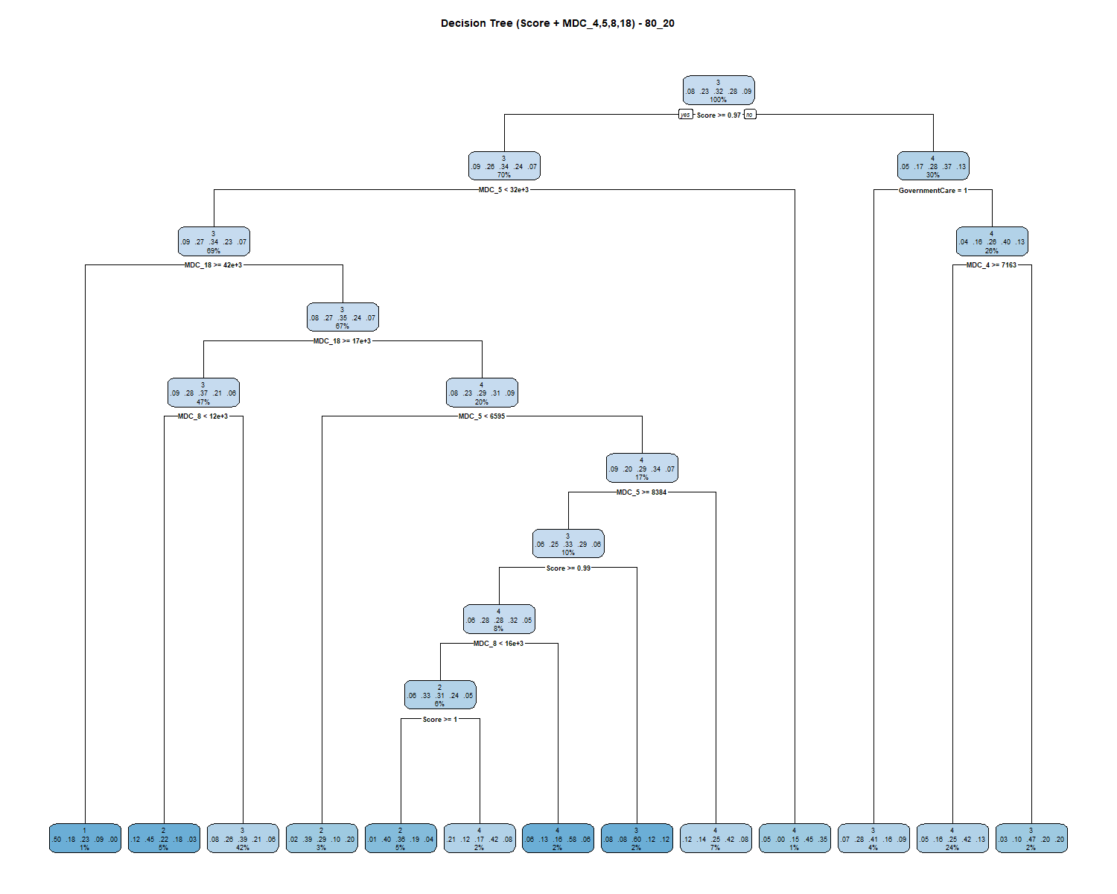
Appendix G - Random Forest Plots

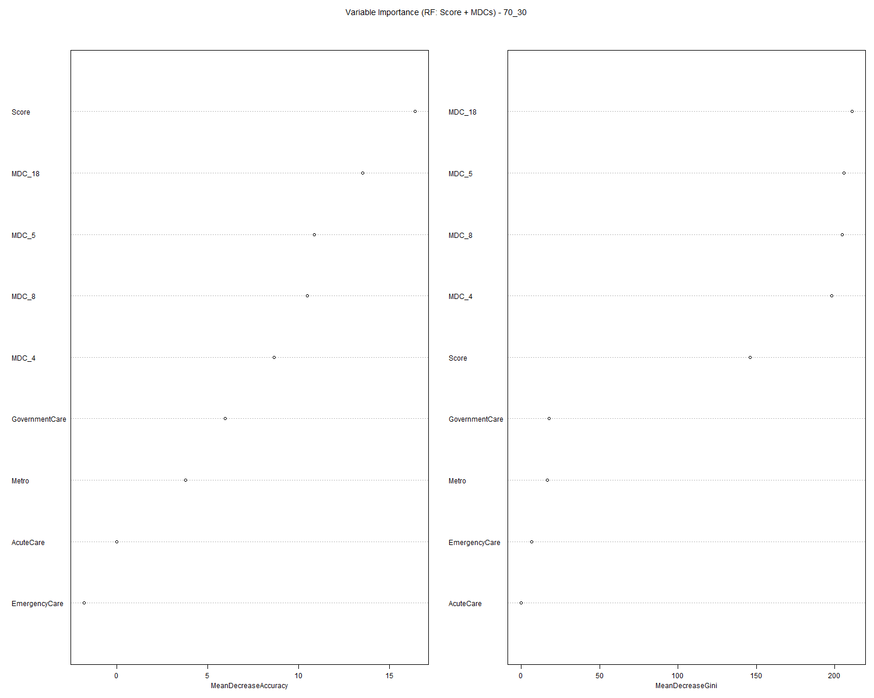

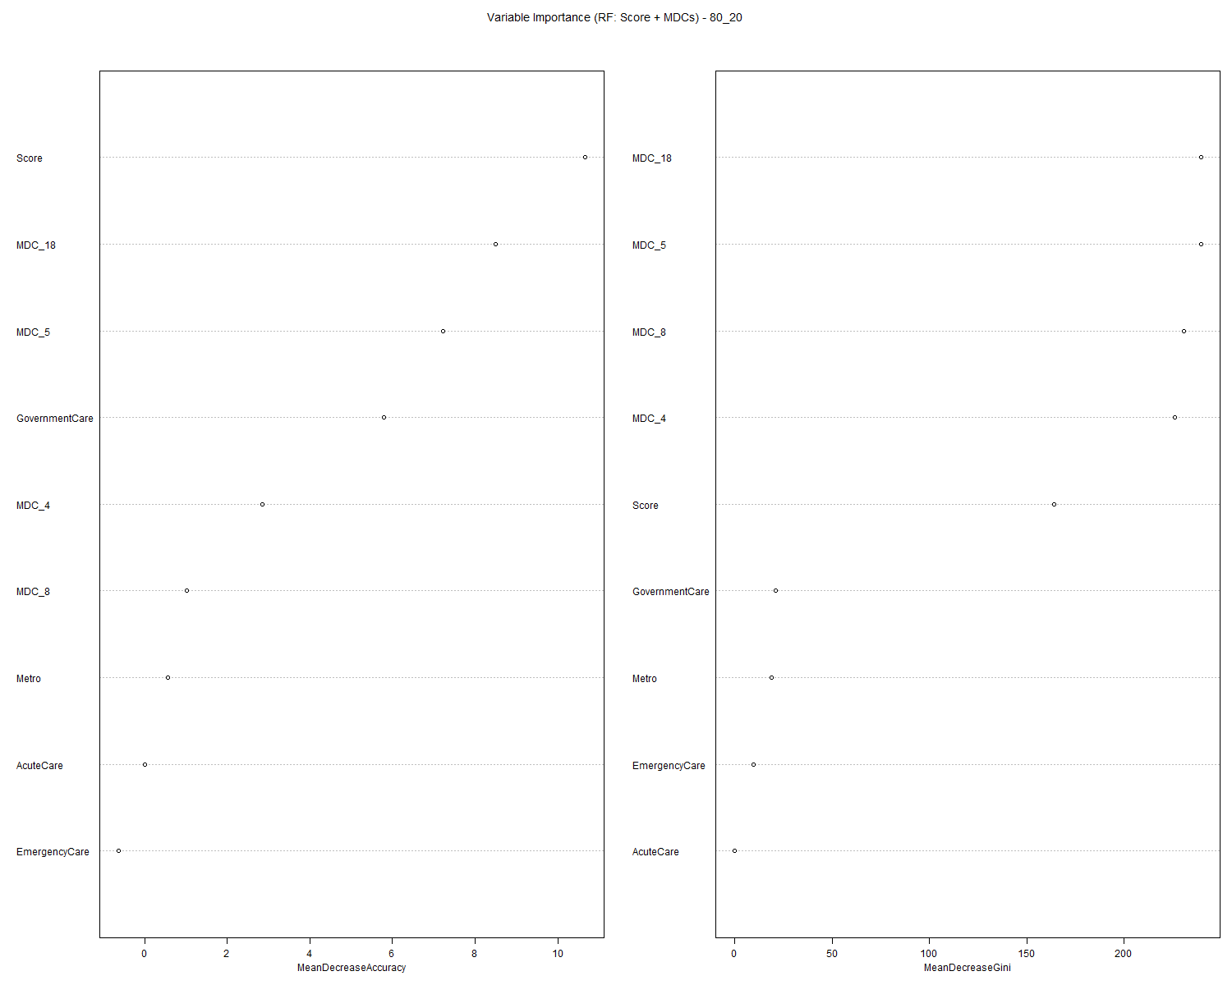

Appendix H - Power BI Dashboard Snapshots

